SIMATS ENGINEERING
ASSESSMENT TOOL 3: Technical Presentation

COURSE NAME: | Cloud Computing and Big Data Analytics | COURSE CODE: | CSA15

COURSE OUTCOME COVERED
CO1: Apply cloud computing technologies including hardware-software evolution, virtualization, web services, and service models to develop cloud-based solutions. (BL2)
Assessment Tool Weightage: 10%

Dave's Taxonomy: Imitation (Level 1)  Question Count: 5 | Total Marks: 25

Code of Conduct
I Yazhini R(192521190) (Name / Reg No) certify that this submission is my original work and that I have adhered to the guidelines specified for this assessment.
I understand that any violation of academic integrity rules will result in disciplinary action.


Signature of the student: ____________________

Assessment Tasks
Technical Presentation Topics
Prepare a 6-8 minute presentation on any one of the following topics. Your slides must include definitions, architecture, industry relevance, and one practical example.
Here are 10 additional technical presentation topics in a similar style, suitable for a 6–8 minute presentation with definitions, architecture, industry relevance, and a practical example:
- Containerization and Cloud-Native Applications: Transforming Modern Software Deployment
  - Explore containers, container architecture, benefits, and a real-world deployment example.
- Serverless Computing: Reducing Infrastructure Management in the Cloud
  - Discuss Function-as-a-Service (FaaS), architecture, business advantages, and practical use cases.
- Edge Computing vs Cloud Computing: Choosing the Right Computing Paradigm
  - Compare architectures, applications, and industry adoption scenarios.
- Microservices Architecture in Cloud Environments
  - Explain microservices design, benefits over monolithic systems, and industry implementations.
- Cloud Security Fundamentals: Protecting Data and Applications
  - Cover security models, shared responsibility architecture, and real-world security practices.
- Multi-Cloud and Hybrid Cloud Strategies for Enterprise IT
  - Analyze deployment models, business benefits, challenges, and practical examples.
- The Role of Artificial Intelligence and Machine Learning in Cloud Platforms
  - Discuss AI/ML cloud services, architecture, and industry applications.
- DevOps and Continuous Integration/Continuous Deployment (CI/CD) in Cloud Computing
  - Explain DevOps principles, CI/CD architecture, and practical implementation examples.
- Cloud Storage Technologies: Object, Block, and File Storage Compared
  - Compare storage architectures, use cases, and industry adoption patterns.
- Internet of Things (IoT) and Cloud Computing: Building Connected Ecosystems
  - Examine IoT-cloud architecture, benefits, challenges, and real-world applications.
- Cloud Migration Strategies: Moving Enterprise Applications to the Cloud
  - Examine migration approaches, cloud architecture considerations, benefits, challenges, and a successful migration case study.
- Big Data Analytics in Cloud Computing
  - Explore cloud-based data processing architectures, analytics platforms, business value, and real-world applications.
- Identity and Access Management (IAM) in Cloud Environments
  - Discuss authentication, authorization architectures, security benefits, and practical enterprise implementations.
- Content Delivery Networks (CDNs) and Their Role in Cloud Services
  - Explain CDN architecture, performance optimization, industry relevance, and examples from popular web platforms.
- Server Virtualization and Its Role in Cloud Computing
Explain virtualization architecture, hypervisors, virtual machines, resource allocation, and the benefits of virtualization in cloud data centers.
- Cloud Storage Technologies and Architecture
Discuss cloud storage concepts, storage architectures, scalability, availability, data replication, and practical applications such as Google Drive and Amazon S3.
- Cloud Security: Threats and Protection Mechanisms
Explain common cloud security threats, data protection, encryption, network security, security controls, and practical approaches used by cloud service providers.
- Infrastructure as a Service (IaaS): Architecture and Applications
Explain the IaaS model, virtual computing resources, storage and networking services, advantages, limitations, and practical enterprise applications.
- Platform as a Service (PaaS) for Cloud Application Development
Discuss PaaS architecture, development environments, application deployment, scalability, advantages, limitations, and examples of PaaS platforms.
- Software as a Service (SaaS): Architecture and Business Applications
Explain SaaS architecture, features, advantages, subscription-based software delivery, security considerations, and examples such as Google Workspace and Microsoft 365.

Minimum slide flow:
- Title
- Aim and objective
- Core technical explanation
- Architecture or process diagram
- Methodology
- Real-world use case
- Conclusion and key takeaway

Technical Presentation Rubric

Criteria | Weightage | Level 4 - Exemplary | Level 3 - Proficient | Level 2 - Developing | Level 1 - Beginning
Technical Content | 30% | Content is highly accurate, relevant, and insightful | Content is correct with minor gaps | Basic content with limited depth | Content is inaccurate or superficial
Structure and Flow | 20% | Excellent logical flow and slide organization | Good structure with minor issues | Some organization but weak flow | Disorganized presentation
Use of Visuals | 15% | Visuals strongly support technical communication | Relevant visuals used well | Limited or unclear visuals | No meaningful visuals
Communication Skills | 20% | Confident, clear, and engaging delivery | Clear delivery with minor hesitation | Moderate clarity but uneven delivery | Weak delivery and low clarity
Professionalism | 15% | Well-prepared and audience-focused presentation | Mostly professional | Basic preparation visible | Poor preparation and professionalism

Topic : Server Virtualization and Its Role in Cloud Computing
Introduction
- Server virtualization creates multiple virtual servers on a single physical server.
- Physical resources are abstracted into virtual CPU, memory, storage and network resources.
- Each virtual machine can run its own operating system and applications.
- A hypervisor manages communication between VMs and physical hardware.
- Virtualization provides isolation between different workloads.
- It enables efficient and flexible use of computing resources

Objective
- Understand the concept and architecture of server virtualization.
- Study virtual machines and their components.
- Understand the working and role of hypervisors.
- Compare physical servers with virtualized server environments.
- Analyze the benefits and limitations of virtualization.

Core technical explanation:
- Server virtualization is a key technology in modern computing infrastructure.
- It enables computing environments to operate independently from physical hardware.
- Hypervisors manage virtual machines and underlying resources.
- Virtualization supports efficient resource sharing and workload isolation.
- It provides a foundation for flexible and scalable cloud infrastructure.

Architecture or process diagram:

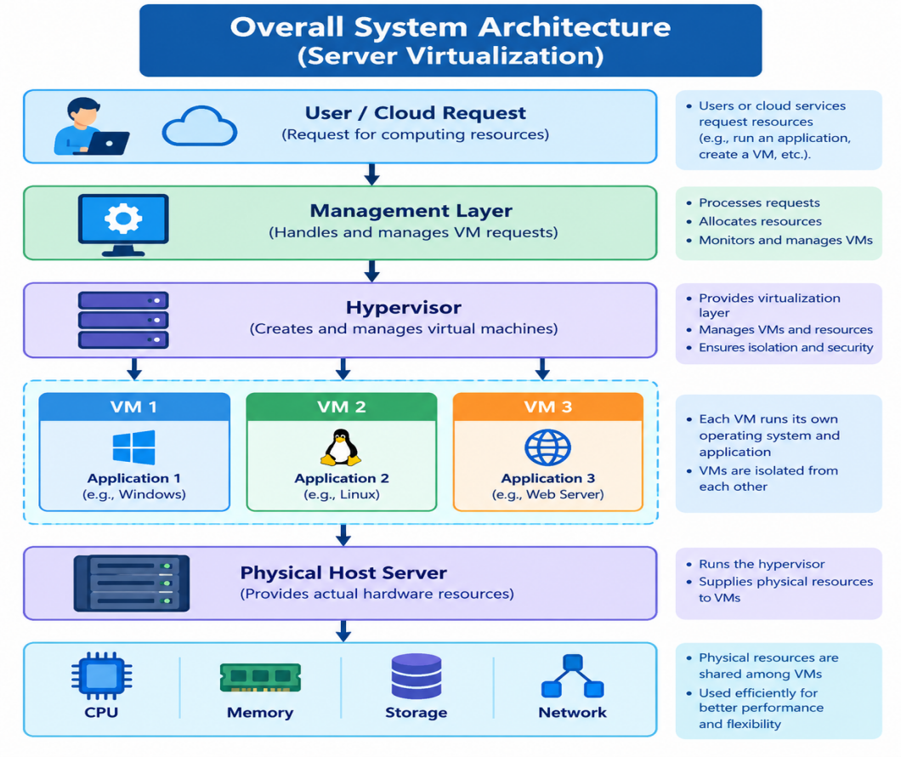
Real-world use case:

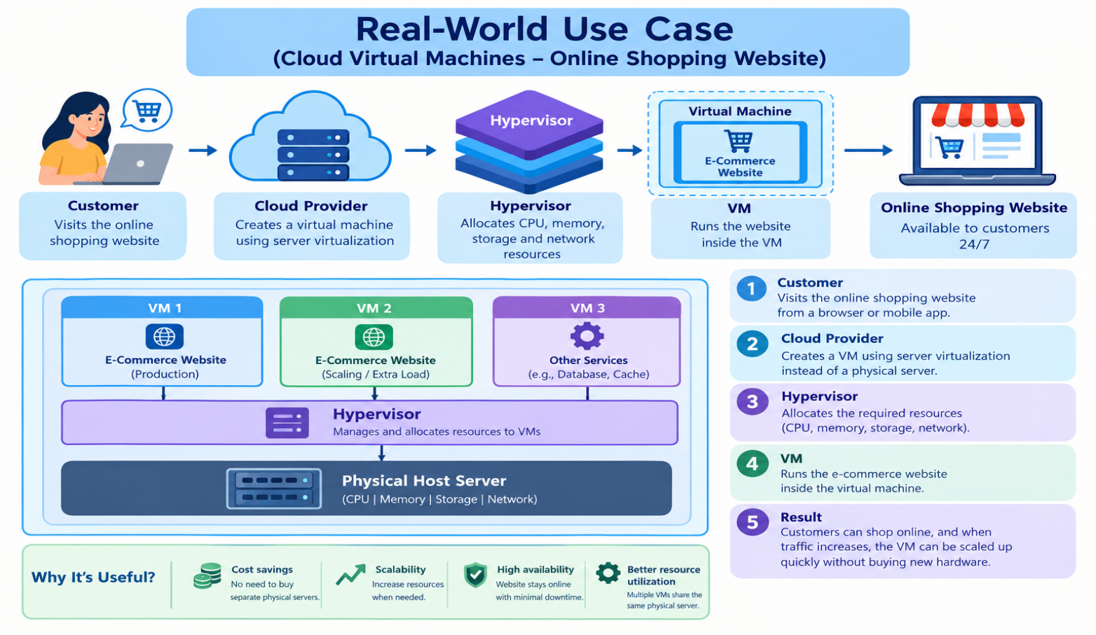

Conclusion and key takeaway:
- Server virtualization converts physical resources into flexible virtual resources.
- Multiple VMs can share the resources of a single physical server.
- Improves CPU, memory, and hardware utilization.
- Reduces hardware, power, and maintenance costs.
- Enables faster provisioning and flexible resource allocation.
- Supports scalability and efficient cloud infrastructure.
- Provides workload isolation through virtual machines.
- Performance, security, resource contention, and management must be considered.

Photo of the presentation :
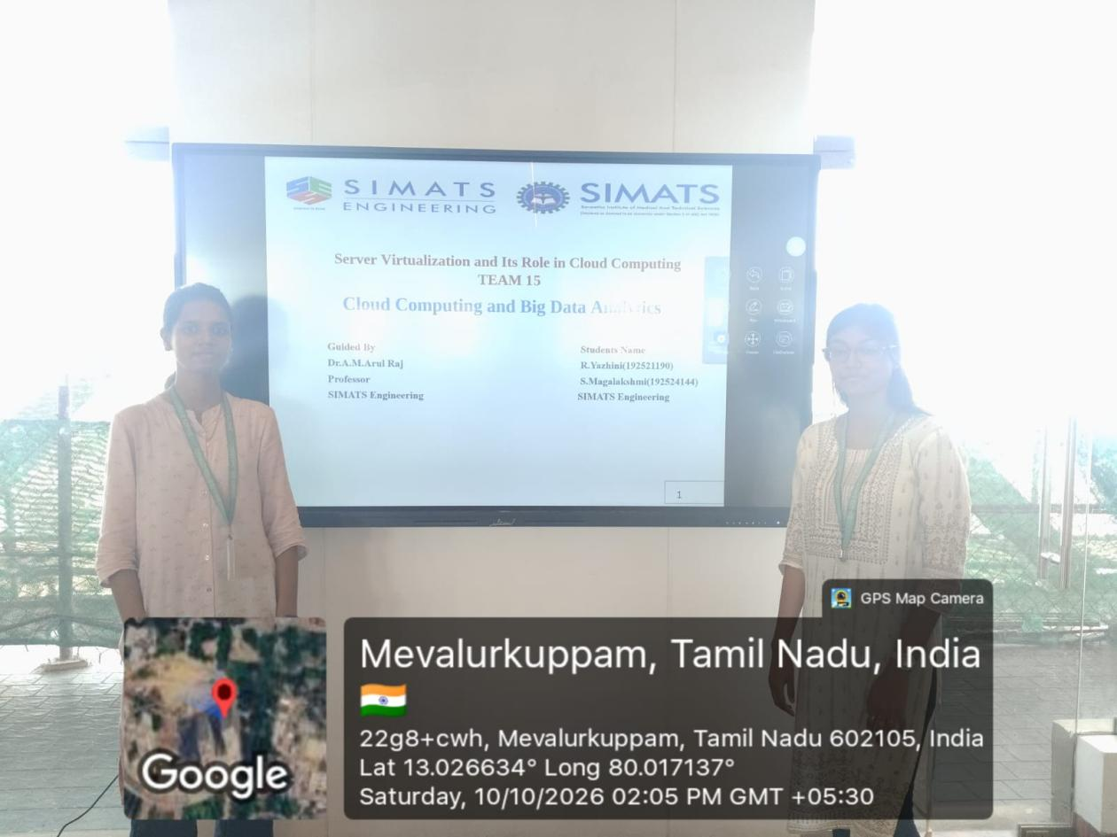

Conclusion :
- Server virtualization converts physical resources into flexible virtual resources.
- Multiple VMs can share the resources of a single physical server.
- Improves CPU, memory, and hardware utilization.
- Reduces hardware, power, and maintenance costs.
- Enables faster provisioning and flexible resource allocation.
- Supports scalability and efficient cloud infrastructure.
- Provides workload isolation through virtual machines.
- Performance, security, resource contention, and management must be considered.

